

Administering Medication Policy
Prepared by: Life Skills Manor
Date: March 2026
Version: V1

CONTENTS
Introduction
Statement of intent
Legal framework
Roles and responsibilities
Training staff
Receiving, storing and disposing of medication
Administering medication
Medical devices
IHPs
Educational trips and visits
Medical emergencies
Monitoring and review
Appendix 1
Contact Information
Approval & Policy Review
Revision History
- Introduction
Life Skills Manor School is owned and operated by Cavendish Education.

This policy is one of a series of school policies that, taken together, are designed to form a comprehensive statement of the school’s aspiration to provide an outstanding education for each of its students and of the mechanisms and procedures in place to achieve this. Accordingly, this policy should be read alongside these policies. In particular, it should be read in conjunction with the policies covering equality and diversity, Health and Safety, safeguarding and child protection.

All of these policies have been written, not simply to meet statutory and other requirements, but to enable and evidence the work that the whole school is undertaking to ensure the implementation of its core values: To Deliver young people aged 10-18 that focuses on preparing students for independent, fulfilling adult lives through a highly tailored curriculum.

While this current policy document may be referred to elsewhere in Supporting Pupils with Medical Conditions School documentation, including particulars of employment, it is non-contractual.

In the school’s policies, unless the specific context requires otherwise, the word “parent” is used in terms of Section 576 of the Education Act 1996, which states that a ‘parent’, in relation to a child or young person, includes any person who is not a biological parent but who has parental responsibility, or who has care of the child. Department for Education guidance Understanding and dealing with issues relating to parental responsibility updated August 2023, considers a ‘parent’ to include:

- all biological parents, whether they are married or not
- any person who, although not a biological parent, has parental responsibility for a child or young person - this could be an adoptive parent, a step-parent, guardian or other relative
- any person who, although not a biological parent and does not have parental responsibility, has care of a child or young person

A person typically has care of a child or young person if they are the person with whom the child lives, either full or part-time, and who looks after the child, irrespective of what their biological or legal relationship is with the child.

The school contracts the services of third-party organisations to ensure regulatory compliance and implement best practices for:
- HR and Employment Law
- Health & Safety Guidance
- DBS Check processing
- Mandatory Safeguarding, Health & Safety, and other relevant training
- Data protection and GDPR guidance
- Specialist insurance cover
Where this policy refers to ‘employees’, the term refers to any individual who is classified as an employee or a worker, working with and on behalf of the school (including volunteers and contractors).

The school is committed to safeguarding and promoting the welfare of children and young people and expects all staff, volunteers, pupils and visitors to share this commitment.

All outcomes generated by this document must take account of and seek to contribute to safeguarding and promoting the welfare of children and young people at Life Skills Manor School.

The policy documents of Life Skills Manor School are revised and published periodically in good faith. They are inevitably subject to revision. On occasions, a significant revision, although promulgated in school separately, may have to take effect between the republication of a set of policy documents. Care should therefore be taken to ensure, by consultation with the Senior Leadership Team, that the details of any policy document are still effectively current at a particular moment.

- Statement of intent
Life Skills Manor School will ensure that pupils with medical conditions receive appropriate care and support at school, for them to have full access to education and remain healthy. This includes the safe storage and administration of pupils’ medication.

The school is committed to ensuring that parents feel confident that we will provide effective support for their child’s medical condition, and make the pupil feel safe whilst at school.

For this policy, “medication” is defined as any prescribed or over-the-counter medicine, including devices such as asthma inhalers and adrenaline auto-injectors (AAIs). “Prescription medication” is defined as any drug or device prescribed by a doctor. “Controlled drug” is defined as a drug around which there are strict legal controls due to the risk of dependence or addiction, e.g. morphine.

Legal framework
This policy has due regard to all relevant legislation and statutory guidance, including, but not limited to, the following:

- Equality Act 2010
- Children and Families Act 2014
- DfE (2015) ‘Supporting pupils at school with medical conditions’
- DfE (2017) ‘Using emergency adrenaline auto-injectors in schools’
- The 6 rights (Rs) of medicines administration

This policy operates in conjunction with the following school policies:

- Supporting Pupils with Medical Conditions Policy
- First Aid Policy
- Complaints Procedures Policy

Roles and responsibilities
The Board of Directors are responsible for:
- The implementation of this policy and procedures.
- Ensuring that this policy, as written, does not discriminate on any grounds, including the protected characteristics as defined by the Equality Act 2010.
- Ensuring the correct level of insurance is in place for the administration of medication.
- Managing any complaints or concerns regarding this policy, the support provided to pupils, or the administration of medication in line with the school’s Complaints Procedures Policy.

The Head Teacher is responsible for:
- The day-to-day implementation and management of this policy and relevant procedures.
- Ensuring that members of staff who administer medication to pupils, or help pupils self-administer, are suitably trained and have access to the information needed.
- Ensuring that staff members understand the local emergency services’ cover arrangements and that the correct information is provided for the navigation system.
- Organising another appropriately trained individual to take over the role of administering medication in case of staff absence.
- Ensuring that all necessary risk assessments are carried out regarding the administration of medication, including for school trips and external activities.
- Ensuring that relevant health and social care professionals are consulted to guarantee that pupils taking medication are properly supported.

All staff are responsible for:
- Adhering to this policy and supporting pupils to do so.
- Carrying out their duties that arise from this policy fairly and consistently.

Parents are responsible for:
- Keeping the school informed about any changes to their child’s health.
- Completing a consent form before they or their child brings any medication into school.
- Discussing medication with their child prior to requesting that a staff member administer the medication.

It is both staff members’ and pupils’ responsibility to understand what action to take during a medical emergency, such as raising the alarm with the Pastoral Staff or other members of staff. This may include staff administering medication to the pupil involved.

Training staff
The Assistant Headteacher will ensure that a sufficient number of staff are suitably trained in administering medication.

Where it is a necessary component of their job role, staff will undertake training on administering medication in line with this policy as part of their new starter induction.
Staff will be informed that administering medication is a voluntary role, unless it is a central part of their duties, such as for the school nurse. This information will be part of their training, allowing them to make an informed decision about taking on this responsibility. The school will advise staff not to agree to administer medication before receiving appropriate training.

Training will also cover the appropriate procedures and courses of action concerning the following exceptional situations:
- The timing of the medication’s administration is crucial to the health of the child
- Some technical or medical knowledge is required to administer the medication
- Intimate contact with the pupil is necessary

Staff members will be made aware that if they administer medication to a pupil, they take on a legal responsibility to do so correctly; therefore, staff will be encouraged not to administer medication in the above situations if they do not feel comfortable and confident in doing so, even if they have received training.

Training for administering AAIs
The school will arrange specialist training for staff on a yearly basis where a pupil in the school has been diagnosed as being at risk of anaphylaxis. Designated staff members with suitable training and confidence in their ability to use AAIs will be appointed to administer this medication. As part of their training, all staff members will be made aware of:
- How to recognise the signs and symptoms of severe allergic reactions and anaphylaxis.
- Where to find AAIs in the case of an emergency.
- How to respond appropriately to a request for help from another member of staff.
- How to recognise when emergency action is necessary.
- Who the designated staff members for administering AAIs are.
- How to administer an AAI safely and effectively if there is a delay in response from the designated staff members.
- How to make appropriate records of allergic reactions.

There will be a sufficient number of staff who are trained in and consent to administering AAIs on-site at all times.

Receiving, storing and disposing of medication
Receiving prescribed medication from parents
The parents of pupils who need medication administered at school will be sent an administering medication parental consent form to complete and sign; the signed consent form will be returned to the school and appropriately filed before staff can administer medication to pupils under the age of 16. A signed copy of the parental consent form will be kept with the pupil’s medication, and no medication will be administered if this consent form is not present.

The school will only store and administer prescribed medication. The school will store a reasonable quantity of medication, e.g. a maximum of one term’s supply at any one time. Aspirin will not be administered unless the school has evidence that it has been prescribed by a doctor.

Parents will be advised to keep medication provided to the school in the original packaging, complete with instructions, as far as possible, particularly for liquid medications where transfer from the original bottle would result in the loss of some of the medication on the inside of the bottle. This does not apply to insulin, which can be stored in an insulin pen.

Storing pupils’ medication
The school will ensure that all medications are kept appropriately, according to the product instructions, and are securely stored. Medication that may be required in emergency circumstances, e.g. asthma inhalers and AAIs, will be stored in a way that allows it to be readily accessible to pupils who may need it and can self-administer, and staff members who will need to administer them in emergencies. All other medication will be stored in a place inaccessible to pupils, e.g. a locked cupboard.

The school will ensure that pupils know where their medication is at all times and can access it immediately, e.g. by ensuring that the identities of any key holders to the storage facilities are known by these pupils.

All controlled medication will be stored in a double-locked cupboard/room. Which is only accessible to authorised and fully trained staff for administering medication.

Medication stored in the school will be:
- Kept in the original container alongside the instructions for use.
- Clearly labelled with:
  - The pupil’s name.
  - The name of the medication.
  - The correct dosage.
  - The frequency of administration.
  - Any likely side effects
  - The expiry date.
- Stored alongside the accompanying administering medication parental consent form.

Medication that does not meet the above criteria will not be administered.

Disposing of pupils’ medication
The school will not store surplus or out-of-date medication. Where medication and/or its containers need to be returned to the pupils’ doctor or pharmacist, parents will be asked to collect these for this purpose.

Needles and other sharps will be disposed of safely and securely, e.g. using a sharps disposal box.

Administering medication
Medication will only be administered at school if it would be detrimental to the pupil not to do so. Only suitably qualified members of staff will administer controlled drugs. Staff will check the expiry date and maximum dosage of the medication being administered to the pupil each time it is administered, as well as when the previous dose was taken.

Medication will be administered in a private, comfortable environment and, as far as possible, in the same room as the medication is stored; this will normally be Earth by the Pastoral team. The room will be equipped with the following provisions:
- Arrangements for increased privacy where intimate contact is necessary
- Facilities to enable staff members to wash their hands before and after administering medication, and to clean any equipment before and after use if necessary
- Available PPE for use where necessary

Before administering medication, the responsible member of staff should check:
- The pupil’s identity.
- The school possesses written consent from a parent.
- That the medication name, dosage and instructions for use match the details on the consent form.
- The name on the medication label is the name of the pupil being given the medication.
- That the medication to be given is within its expiry date.
- The pupil has not already been given the medication within the accepted frequency of dosage.

If there are any concerns surrounding giving medication to a pupil, the medication will not be administered, and the school will consult with the pupil’s parent or a healthcare professional, documenting any action taken.

If a pupil cannot receive medication in the method supplied, e.g. a capsule cannot be swallowed, written instructions on how to administer the medication must be provided by the pupil’s parent, following advice from a healthcare professional.

Where appropriate, pupils will be encouraged to self-administer under the supervision of a staff member, provided that parental consent for this has been obtained. If a pupil refuses to take their medication, staff will not force them to do so, but will follow the procedure agreed upon in their IHPs, and parents will be informed so that alternative options can be considered.

The school will not be held responsible for any side effects that occur when medication is taken correctly.

Written records will be kept of all medication administered to pupils, including the date and time that medication was administered and the name of the staff member responsible. Records will be stored on our MIS system AIMS and a paper record kept in Earth.

Medical devices
Asthma inhalers
The school will ensure that spare inhalers for pupils are kept safe and secure in preparation for the event that the original is misplaced, unavailable or not working.

AAIs
The school will ensure that spare AAIs for pupils are kept safe and secure in preparation for the event that the original is misplaced, unavailable or not working.

Spare AAIs are not located more than five minutes away from where they may be required. The emergency AAIs can be found at the following locations:
- Earth

Medical authorisation and parental consent will be obtained from all pupils believed to be at risk of anaphylaxis for the use of spare AAIs in emergencies. The spare AAIs will not be used on pupils who are not at risk of anaphylaxis or where there is no parental consent. Where consent and authorisation have been obtained, this will be recorded in the pupil’s IHP.

IHPs
For pupils with chronic or long-term conditions and disabilities, an IHP will be developed in liaison with the pupil, their parent, SLT, The Pastoral staff, the SENCO and any relevant medical professionals. When deciding what information should be recorded on an IHP, the following will be considered:
- The medical condition and its triggers, signs, symptoms and treatments
- The pupil’s resulting needs, such as medication, including the correct dosage and possible side effects, medical equipment, and dietary requirements
- The specific support needed for the pupil’s educational, social and emotional needs
- The level of support needed and whether the pupil will be able to take responsibility for their own health needs
- The type of provision and training that is required, including whether staff can be expected to fulfil the support necessary as part of their role
- Which staff members need to be aware of the pupil’s condition
- Arrangements for receiving parental consent to administer medication
- Separate arrangements may be required for out-of-school trips and external activities
- Which staff member can fulfil the role of being a designated, entrusted individual to whom confidentiality issues are raised
- What to do in an emergency, including whom to contact and contingency arrangements
- What is defined as an emergency, including the signs and symptoms that staff members should look out for

The Head Teacher will ensure that IHPs are reviewed at least Annually IHPs will be routinely monitored throughout the year by the Staff mentioned above

Educational trips and visits
In the event of educational trips and visits which involve leaving the school premises, medication and medical devices will continue to be readily available to staff and pupils. This may include pupils carrying their medication themselves, where possible and appropriate, e.g. for asthma inhalers.

If the medication is of a type that should not be carried by pupils, e.g. capsules, or if pupils are very young or have complex needs that mean they cannot self-administer, the medication will be carried by a designated staff member for the duration of the trip or activity.

There will be at least one staff member who is trained to administer medication on every out-of-school trip or visit that pupils with medical conditions will attend. Staff members will ensure that they are aware of any pupils who will need medication administered during the trip or visit, and will ensure that they know the correct procedure, e.g. timing and dosage, for administering their medication.

If the out-of-school trip or visit will be over an extended period of time, e.g. an overnight stay, a record will be kept of the frequency at which pupils need to take their medication, and any other information that may be relevant. This record will be kept by a designated trained staff member who is present on the trip and can manage the administration of medication.

All staff members, volunteers and other adults present on out-of-school trips and visits will be made aware of the actions to take in a medical emergency related to the specific medical needs and conditions of the pupil, e.g. what to do if an epileptic pupil has a seizure.

Medical emergencies
Medical emergencies will be handled in line with the First Aid Policy.

For all emergency medication stored by the school, the school will ensure it is readily accessible to staff and the pupil who requires it, and is not locked away. For all emergency medication kept in the possession of a pupil, e.g. AAIs, the school will ensure that pupils are told to keep the appropriate instructions with the medication at all times. A spare copy of these instructions will be kept by the school in the school nurse’s office.

Monitoring and review
Records of medication administered on the school premises, or on school trips and visits, will be monitored, and the information recorded will be used to improve school procedures.
Staff members trained in administering medication will routinely recommend any improvements to the procedure. The school will also seek advice from any relevant healthcare professionals as deemed necessary. Any changes made to this policy will be communicated to the relevant stakeholders, including pupils whose medication is stored at school and their parents.

Appendix 1
Parental agreement to administer medication

Appendix 2
Record of medication

Appendix 3
Paracetamol Administer Form

Approval & Policy Review

This Policy has been reviewed and approved by:

Policy Approver(s) | Cavendish Education Board of Directors/Senior Leadership Team of the school/ Assistant Headteacher
Storage Location | Online, School Website
Effective Date | March 2026
Next Review Date | March 2027

Revision History

Version | Change | Author | Date of Change
1 | First published | Craig,Kelly Assistant Headteacher | March 2026

Appendix 1



PARENT AGREEMENT
FOR TRAINED STAFF
TO ADMINISTER MEDICATION

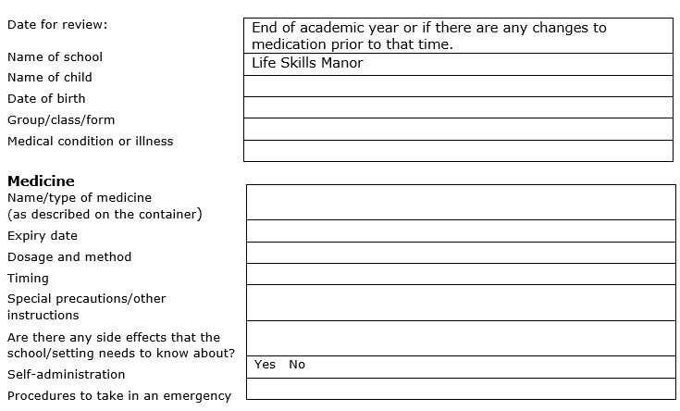
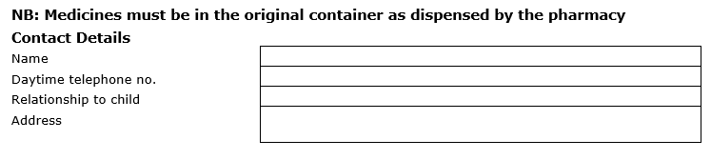
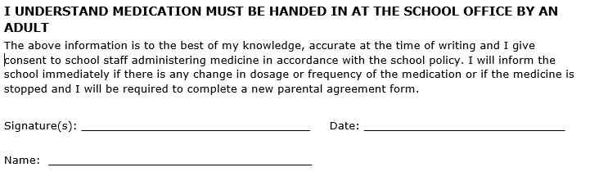
Appendix 2

RECORD OF MEDICATION –

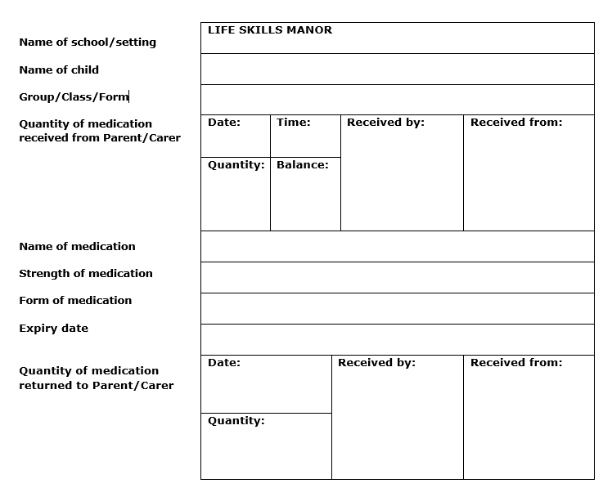

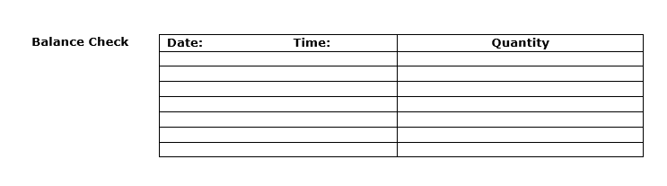

Appendix 3

Paracetamol Administer form

Date:

Dear Parent/Carer

Re: _

In accordance with our medication policy and the consent form signed by you this is to inform you that the above-named pupil was given the following medication for the relief of pain:

Paracetamol: Dosage: _ Time: _

Calpol: Dosage: _ Time: _

The condition for which this medication was required: _

