

Child Friendly Safeguarding Policy
All the adults at Life Skills Manor care about you and think that your health, safety, and welfare are so very important.
- We will do our best to help you make good educational progress.
- We want to give you a safe place to learn in.
- We will help keep you safe, at home as well as at school.

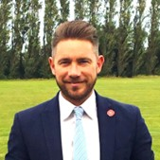
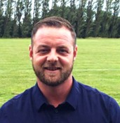

- It is important that you know where to get help if you are worried or unhappy about something.
If you need to talk – we will always listen to you
● You can talk to any adult at school.
- You need to know that Mr Capeling, Mr Barrett, Mr Kelly and Mr Walker are responsible for making sure you are safe and well.
- If you need a friend to go with you to tell a grown up something that is worrying you, that is fine.

Do not keep it a secret if someone is:
- Bullying you.
- Saying things, you do not like or upsets you.
- Sending unkind messages on the internet or phone.
- Touching you in a way you do not like, for example, touching your private parts.
- Making you look at things which make you feel uncomfortable, ashamed, guilty, or embarrassed.
- Hitting you or hurting you.
- Trying to give you cigarettes, drugs, or alcohol.
- Making you feel sad or scared.
- Giving you presents. Receiving presents is usually ok but sometimes people try to trick children into doing something that is wrong by giving them presents like sweets, money, or phones.

It is important that you know:
- All children have the right to feel happy and safe.
- It is never your fault if someone is hurting or abusing you.
● There is always an adult at school who will help you.


Childline – 0800 11 11, www.childline.org.uk, www.thinkyouknow.co.uk

