

Equality Scheme Policy

Date – February 2026

Contents

1. Single Equality Scheme - Equalities Policy 3
2. School Philosophy 3
3. Strategies 5
4. Success Criteria 5
5. Monitoring and Review 5
6. Racism 6
7. Aims 6
8. Objectives 6
9. Governors and Staff 7
10. Pupils 8
11. Parents/Carers and Visitors or Contract Staff 8
12. Racial Incident Procedure 8
13. Monitoring of Racial Incidents 10
14. Reporting Information to Parents, Governors, and the LEA 11
15. Examples of Racist Incidents 11
16. Appendix 1 - Racial Incidents Report Form 12
17. Appendix 2 - Disability Equality Scheme and Accessibility Plan 18
18. Appendix 3 - Gender Equality Action Plan 20

Single Equality Scheme - Equalities Policy

Life Skills Manor aims at all times to promote policies and practises that will meet its duties to promote equality of opportunity for and between diverse members of the school community, including disabled pupils, staff and parents, women, men, and different racial groups within the school.

Life Skills Manor wholeheartedly supports the principle of equal opportunities and opposes all forms of unlawful or unfair discrimination on the grounds of:

- Sex
- Race including colour, nationality, ethnic or national origin
- Disability (including medical conditions)
- Religion
- Religious belief or philosophical belief
- Sexual orientation
- Trade Union activity
- Age
- Responsibility for dependents
- Gender re-assignment
- Maternity and pregnancy
- Marriage and civil partnership

The school will seek to

- Eliminate unlawful discrimination, harassment, and victimisation
- Promote equality of opportunities
- Foster good relations

We will do this by adopting the following policies, procedures, and action plans

- Equal Opportunities Policy

- Race Equality Policy

- Disability Equality and Accessibility Plan (Appendix 2)

- Gender Equality Action Plan (Appendix 3)

School Philosophy

School Philosophy
Kent Education Authority and Life Skills Manor are committed to the general principle of equal opportunity for all members of the school community, irrespective of age, culture, race, religion, sex, marital status, language disability, gender and sexual orientation or family background, and to the active support of initiatives designed to further the principle that everyone has the right to be seen, treated, and recognised on their individual merits without prejudice.

Discrimination of any form can be either overt or covert, and the school recognises that there is a need to identify and to take action to counter all kinds of discrimination. To this end we endeavour at all times to provide a learning environment which:

- Promotes the principles of fairness and justice for all.
- Overcomes bias and conditioning
- Openly involves discussion on issues of equal opportunities
- Encourages the sampling of non-traditional roles or work
- Avoids stereotyped roles when grouping staff or pupils
- Eliminates bias in learning materials as far as possible
- Supports positive discrimination where this is needed in certain areas of the curriculum e.g. single sex groups, smaller groups etc.

It is the responsibility of the Governing Body to ensure that there is a current Equal Opportunities Policy that entitles everyone to equal consideration.

Within this general principle, the following statements should apply:

- All pupils will have equal access to the whole curriculum.
- The school will review its teaching materials and select any new materials to ensure that they are free from racist, sexist, and other discriminatory assumptions.
- The importance of Careers Education Counselling is recognised. Guidance should be non-discriminatory and should encourage pupils to consider non-traditional areas of employment.
- At appropriate points in the school's teaching programme the issues of sex stereotyping and sexism will be brought to the attention of pupils.
- Recruitment and promotion of staff for all positions within the school should be carried out in a manner consistent with equal opportunities practice.

Life Skills Manor Equal Opportunities Policy

The school will promote equal opportunities provision by:
- Delivering a broad and balanced curriculum for all pupils.
- Requiring staff with subject responsibility to consider and respond to opportunities for addressing the issues of race, sex, disability, social disadvantage and including aspects of individual sexuality.
- Monitoring its syllabuses, teaching materials and resources to ensure they reflect an entitlement to equality.
- Ensuring that Equal Opportunities issues are addressed within staff, pastoral and curriculum meetings.
- Giving consideration to specialised groupings where pupils can be helped to acquire non-traditional skills free from peer group pressure.
- Seeking to avoid gender stereotyping in careers guidance and work experience placements of pupils.
- Ensuring that there are adequate facilities available to enable all pupils, regardless of physical disability, to have access to the curriculum and its resources.
- Ensuring that programmes of Personal, Social and Health Education and acts of collective worship are used as vehicles to promote the dignity, worth and essential equality of the whole school community.
- Investigating all anti-social incidents with rigour and a commitment to developing understanding and combating ignorance.

Strategies

To support the implementation of this policy, the following strategies will be adopted:
- An aim to purchase bias-free resources and to review present resources for bias-free images of race, gender, and disability.
- Careful choice of display materials to promote positive images of race, gender, and disability.
- Subject leaders will consider/address issues of Equal Opportunities when writing/revising their policies.
- Staff attitudes and practices will promote Equal Opportunities.
- The organisation of the environment and teaching groups will take into account issues of Equal Opportunity.
- Staff will be expected to uphold the recommendations of the Equal Opportunities Policy and to offer positive role models to all pupils.
- Endeavour to ensure that all communications with parents are accessible and appropriate, in ways that take account of their needs e.g. letter, visit, phone call, interpreter.
- Pupils will be supported to make non-stereotypical choices as they see fit.
- Work placements, subject to Health and Safety considerations, are negotiated for all pupils.

Success Criteria

The following criteria will be used to judge the success of the policy.
- Pupils throughout the school accept mixed gender teaching groups
- e.g. Technology, Food Technology, Personal, and Social & Health Education, as the norm.
- In class discussions, the opinions/views of the least able or most shy will be sought and respected, as will their right not to contribute.
- Work experience placements will reflect the Equal Opportunity policy as far as possible.
- All members of the school community voice or show by their actions an understanding, tolerance and or empathy for opinions, actions or lifestyles that differ from their own.

This document is intended to work in conjunction with the following policies and procedures:

Behaviour Policy
Health & Safety Policy
Complaints Policy
KCC Traveller Education Policy

Monitoring and Review

The governing body will monitor the effectiveness of this Equal Opportunities Policy. The governing body will do this by:
- Monitoring the staff appointment process, so that no-one applying for a post at this school is discriminated against.
- Taking into serious consideration any complaints regarding equal opportunity issues from parents, staff, or pupils.
- Monitoring the school behaviour and exclusions policy, so those pupils from minority groups are not unfairly treated.

Racism

Life Skills Manor is a special school of over 150 people, both adults and pupils. We believe that everyone in the school is of equal value and should have equal opportunities in school and the community and in life.

We accept the following definition of racism and institutional racism included in the Stephen Lawrence Inquiry Report: -

Racism – Conduct or words which advantage or disadvantage people because of their colour, culture, or ethnic origin.

Institutional racism – The collective failure of an organisation to provide an appropriate and professional service to people because of their colour, culture, or ethnic origin. It can be seen or detected in processes, attitudes and behaviour which amount to discrimination through unwitting prejudice, ignorance, thoughtlessness, and racist stereotyping which disadvantage minority ethnic people.

Many people in our society are discriminated against and treated as if they are worth less than others because of their race, religion, or language. This will not happen in our school.

People are individuals and therefore different. They have different needs and different contributions to make to the life of our school and of the community. The staff and governors for their part strive to give unconditional trust and ask of pupils that they endeavour to be honest, respect other people and their property. There may be times when the relationship between staff and a pupil breaks down. In such cases the school will give all the support it can to the pupil concerned and his or her parents even though redress to exclusion may be necessary.

Racial Equality is not about treating everybody the same. It is about meeting people’s individual needs and appreciating their individual strengths and gifts. We are all different and should all be equally valued.

Aims

- Our main aim is to offer an education appropriate to each individual pupil’s needs regardless of their race, colour, ethnic or national origins, or religious beliefs.
- With regard to the statutory Code of Practice on the duty to promote race equality, we aim to tackle racial discrimination and to promote equality of opportunity and good race relations across all areas of school activity.
- We aim to ensure that everyone at the school, (staff, pupils, parents, contractors, and visitors) is afforded the basic rights of freedom and access to opportunity, including freedom from all forms of harassment or bullying.
- We aim to ensure that active encouragement is given to all in order to enable them to fully develop talents and personal skills for cooperative interaction and academic excellence. No one person has the right to deny another person of his or her educational opportunity.
- Where contractors are working on site, measures will be taken to ensure their employees operate according to the school’s equal opportunities and racial equality policies and code of practice.

Objectives

- To regard all our pupils as being of equal value and to ensure that the needs of all pupils are identified and met and that they are able to achieve their full potential, helping to raise standards across the school.
- To take direct action (including providing resources and mentoring/counselling support) to remove inequalities between racial groups in their levels of achievement and progress; their experience of disciplinary measures (such as exclusions) or admissions. This will be reflected by particular emphasis on action plans to promote social inclusion and the raising of levels of attainment.
- To challenge, in a positive way, any form of racial prejudice, whether overt or covert, which contradicts the school’s equal opportunities and racial equality policies and codes of conduct. This means adopting a consistent and unambiguous stand, from which we strive to overcome prejudice and ensure equality of opportunity for all, thus protecting the rights and liberties of every individual.
- To foster self-esteem and respect for each person as an individual and to create a positive and inclusive atmosphere where there is a shared commitment to respect diversity and difference, challenge and prevent racism and discrimination, and encourage good relationships between people of different racial groups.
- To prepare pupils to be good citizens, living and working in a multiethnic society and to take up the responsibility of participation and to treat all others as we would wish to be treated. The PSHE and Citizenship programme and the agendas of the School Council will play key roles in achieving this objective.
- To create and retain a workforce that is valued for their diverse contributions and represents different perspectives, ethnic backgrounds, experience, and skills. To achieve this the school will encourage strong community/parental and governor’s links.

Our key guidelines are that:

All pupils should be encouraged to value their own cultural heritage and the culture and lifestyles of others, and to show respect for self and others while at the same time finding common ground to talk to one another and valuing living together in a community.
Every member of staff needs to accept responsibility for establishing a reasonable climate for debate and extending opportunities for controversial discussion. They must address widely held misconceptions to avoid the risk of pupils with limited experience arriving at consensus views of doubtful validity.
The provision of genuine equality of opportunity must be inherent in the education the school offers. The curriculum opportunities must be open to all and must give access for both sexes to all subjects. The school must challenge any gender stereotyping, which leads to constraints on the development of pupils’ abilities and aspirations.
The school should clearly demonstrate the unacceptability of attitudes, incidents, taunts, or remarks that give offence, intimidate, devalue another’s view or opinion, or undermine another’s self-esteem.
More specifically this means the following codes of practice for governors and staff, pupils, parents and carers, visitors, and contract staff.

Governors and Staff

- Staff will treat each other and all pupils with dignity and respect.
- Staff will examine the ideas and images in books and other resources and will challenge negative images and give all pupils positive images.
- Policies on displays, notices, meals, uniform, etc. in the school will reflect our multi-cultural society.
- The school values the fact that pupils may be bilingual and will take positive action to ensure communications are accessible to all.
- Positive links will be developed with the homes of pupils and communities from which our pupils come.
- Preventing and dealing with discriminatory behaviour, abuse, bullying, and intimidation is the responsibility of us all. The school will support victims of such incidents, on or off the premises.
- Appointment and promotion of staff will be made and monitored in accordance with the school’s Equal Opportunities Policy. The governing body will monitor the balance at all levels of gender and ethnicity as well as membership of the governing body.
- The school will take reasonable steps to prevent sexual harassment of their workers.

Pupils

- All pupils are valued for themselves and can expect to have their culture and language treated positively and with respect.
- Pupils will be given the opportunity in the classroom to discuss and to identify and understand racism, sexism, and other forms of prejudice.
- Pupils will be able to contribute to the development of equal opportunities and other school policies through the School Council and Citizenship programme.
- If pupils feel they have been abused racially or bullied they should report the matter immediately to any adult who will refer the matter to the class teacher and a member of the leadership team.
  - All pupils can expect to be listened to and have their complaints investigated. If a pupil feels their complaint has not been properly dealt with they should take the matter to the Headteacher.
- Pupils who have suffered racist or sexist behaviour, abuse, bullying or intimidation will be supported by the school and, in particular, their class teacher. Anyone who has committed such offences will be appropriately dealt with – in the case of pupils this may include exclusion from the school.
- All pupils should treat each other and staff with respect.

Parents/Carers and Visitors or Contract Staff

- Parents/carers are very important to the school and, in particular, they have much to contribute to our equal opportunities policies; their views are welcome and valued at all times. We ask that all parents/carers fully support the school’s Equal Opportunities and Racial Equality Policies.
- The school will discuss with parents/carers any incidents of racist or sexist abuse or bullying in which their sons or daughters have been involved.
- If parents/carers are aware of incidents of racism, sexism, or bullying, they should contact their child’s class teacher or a senior member of staff at the earliest opportunity.
- Any visitors or contract staff visiting or working at the school who become aware of any incidents of racism or sexism should report them to the Headteacher or one of the leadership team. Contractors should also abide by the code of conduct established by the school in relation to equal opportunities and racial equality.

Implementation

- The school has a procedure for dealing with racial incidents.
- Racial Incident Report Form

Racial Incident Procedure

Procedure for dealing with Racial Incidents

If an incident involves employees of the Local Authority (LA), then the Local Management Procedures on Harassment, Grievance or Discipline may be applicable. The following steps are to be taken in dealing with racial incidents which involve pupils.

1. Support the Victim

The following procedure to be followed if a pupil is the victim of a racial incident:

- To investigate the incident and to take appropriate action to offer support to the victim.
- If necessary, meet with the pupil’s parents/guardian to discuss the matter and explain the action taken. The service of an interpreter/translator may be needed at the meetings.
- To record the incident on a Racial Incident Monitoring Form (Appendix 1).

2. Dealing with the Perpetrator

The following procedure is to be followed if a pupil is believed to be behaving in a racially discriminatory way:

- An appropriate member of staff should intervene and take immediate action, for example, separating the victim from the perpetrator.
- Any racist behaviour should be challenged immediately and openly. The perpetrator to be told that his/her behaviour is unacceptable and will not be tolerated.
- The incident should be reported to the Headteacher who will decide whether any further action needs to be taken, including informing the parents/guardian of the relevant pupils.
- The Racial Incident Monitoring Form should be completed as soon as possible.

The following procedure is to be followed if a member of staff or member of the public is believed to be behaving in a racially discriminatory way:

All members of staff are required to abide by the School’s Equal Opportunities Policy. Substantiated racial discrimination by any member of staff towards a pupil may be considered as misconduct and the perpetrator may be subject to disciplinary action. In the event of such an allegation being made against a member of staff, the Headteacher or his nominee will investigate the allegation in accordance with the relevant Disciplinary Procedures.

Racially motivated conduct by members of the public needs an immediate response.

- The incident to be reported to the Headteacher as soon as possible.
- The police to be informed if the incident is of a magnitude that warrants such action (e.g. damage or threat of damage to person or property).
- The Racial Incident Report Form should be completed. The pupil’s parents/guardian and Chair of the Governing Body should be informed of the incident as appropriate.

3. Dealing with the impact on the School and the Community

- Racist graffiti or slogans should be reported and removed as soon as possible.
- Racist literature, badges and insignia should be confiscated. A clear explanation setting out the reasons why the property has been confiscated should be given. The confiscated property may be handed to the police in criminal proceedings or returned to the pupil or his/her parents at the earliest opportunity. It is not permissible for a teacher to deliberately destroy a confiscated item unless it is necessary in the immediate interests of safety.
- If the incident has caused damage or is seen as a threat of damage to a person or property, it may be appropriate to call a special meeting either with staff only, or with pupils as well, to discuss what has happened.
- It may be appropriate to develop a training programme to help pupils as well as teachers to deal with racial incidents.

4. Incidents involving violence or criminal behaviour

For incidents of a serious nature involving violence or criminal behaviour, the Headteacher may feel it is necessary to inform the police, irrespective of the ‘status’ of the perpetrator, i.e. pupil, staff, or members of the public. The Area Education Officer should be informed immediately to facilitate consultation and the possible procuring of advice including legal advice. This is necessary to ensure the Director, or a senior colleague is able to give the fullest advice and where appropriate, inform leading members of the Council, relevant community groups and liaise with the police.

5. Legal Procedures dealing with children under 16

Juveniles must not be interviewed at their place of education or asked to provide or sign a written statement in the absence of an appropriate adult except in exceptional circumstances and only where the Headteacher or his nominee agrees. Every effort should be made to notify the parents/guardian that the police want to interview the juvenile and to ensure their presence at the interview.

Where waiting for the appropriate adult would cause unreasonable delay, and unless the interviewee is suspected of an offence against the school or the staff, the Headteacher or his nominee can act as the appropriate adult for the purpose of the interview.

An interview is the questioning of a person regarding his/her involvement or suspected involvement in a criminal offence or offences. While a juvenile is being interviewed, the appropriate adult can be:

- A parent or guardian (or, if he/she is in care, the care authority or voluntary organisation)
- A social worker
- Failing either one of the above, another responsible adult aged 18 or over who is not a police officer or employed by the police. The role of the adult is to advise the juvenile and to observe whether or not the interview is being conducted properly.

A juvenile should not be arrested at his/her place of education unless this is unavoidable. In this case the Headteacher or his nominee must be informed.

Monitoring of Racial Incidents

1. Rationale

It is necessary to monitor racial incidents in order to:

- Obtain a full picture of the level and nature of racial incidents.
- Measure the effectiveness of the school’s and LA’s Anti-Racist procedures used to deal with racial incidents.
- Prioritise and focus resources to deal with racial incidents at grassroot level.
- Work with other agencies to combat racial incidents in the community.

2. Procedure

- The Headteacher will have overall responsibility for dealing with such incidents and will ensure that the requirement to investigate, record and report where there is a perception that an incident has taken place will be widely publicised.
- The Racial Incident Report Form should be completed as soon as possible after an incident has taken place.
- The Racial Incident Report Form is kept in the Headteacher’s office. It should not be sent to the LA. It will be kept for a period of 5 years.
- The Headteacher will ensure that the commitment to tackling racial incidents and any anti-racist guidelines or equal opportunities statements are well publicised. Copies of the policy statement/procedure can be translated into minority languages where appropriate.

Reporting Information to Parents, Governors, and the LEA

Parents and governors will be informed of the nature of any incident and the action taken to deal with it. The governing body will inform the LA of the pattern and frequency of any such incidents. The LA will collect collated information from schools on an annual basis.

Examples of Racist Incidents
- Derogatory name calling, insults and racist jokes.
- Verbal abuse and threats.
- Racist graffiti.
- Provocative behaviour such as wearing racist badges or insignia.
- Racist comments in the course of discussions.
- Ridicule of an individual’s culture differences, e.g. food, music, dress, religion, language etc.
- Bringing racial materials such as leaflets, comics, or magazines into the institution.
- Attempts to recruit other pupils and students into racist organisations.
- Physical assault which is racially motivated.
- Damage caused to a person’s property, which is racially motivated.
- Incitement to others to behave in a racist way.
- Refusal to co-operate with other people because of their ethnic origin.

Appendix 1 - Racial Incidents Report Form

Section 1 – Details of Victim

Name of victim: …………………………………………………………………………………………………………………

Is the victim:

- A pupil Yes /No

If yes, complete pupil no: ……………………………….……………..

- A member of staff/governor Yes /No

- A pupil from another school Yes /No

- Other (e.g. visitor, parent, contractor) Yes /No

If (b), (c) or (d):

What is the Ethnicity* of the victim? ……………………………………………………..…………………

Is the victim:

An Asylum Seeker/Refugee Yes /No

Record contact details if appropriate

………………………………………………………………………………………………………………..…………………………..

Have there been previous incidents involving the same victim (if known)? Yes /No

*Use categories at end of document

Section 2 – Details of the Perpetrators

Record details of each perpetrator (if more than one)
Name | Pupil in the school? (If Yes give pupil number) | Member of staff or  governor?  Yes/No | Pupil from another school?  Yes/No | Other? (please specify) | Indicate if involved in previous  incidents  Yes/No | Please complete if not a pupil in the school
 |  |  |  |  |  | Ethnicity* | Asylum  Seeker or  Refugee  Yes/No

Section 3 – Date and Type of Incident

When did the incident take place? Date: ………………….…….. Approximate Time: ……….………..

Location (if not in school): …………………………………………………………………………...

What type of incident occurred?

Verbal Abuse Yes /No Physical Abuse Yes/No

Graffiti Yes/No Threatened Assault Yes/ No

Attacks on Property Yes/ No Other (please specify)

What happened (in brief)?

………………………………………………………………………………………………………………………………………………………

………………………………………………………………………………………………………………………………………………………

Section 4 – Action taken to deal with the Incident

Following investigation of the incident was further action undertaken: Yes /No

If so, what was this?

Warning to the perpetrator Yes/ No

Mediation Yes/ No

Referral to Police or other body Yes/ No

Detention Yes/ No

Exclusion Fixed Term Yes/ No If fixed term, how many days ……………..

Exclusion Permanent Yes/ No

Other sanction (please specify) ……………………………………………………

Other action (please specify) ………………………………………………………

If no action was taken, why was this (e.g. there was no case to answer to)? ………………………....

……………………………………………………………………………………………………………………….……………………….

Section 5 – Action taken to support Victim

What action was taken to support the victim (in brief)?

…………………………………………………………………………………………………………..……………………………………………....

…………………………………………………………………………………………………………………………………………………………….

Section 6 – Involvement of the Police

If the Police were involved was this through:

Liaison with the local Youth Crime Reduction Officer: Yes /No

Referral to the local Police Station Yes /No

If appropriate, please record additional details, e.g. date of referral, Police Officer involved, charge made by Police etc.

…………………………………………………………………………………………………………….……………………………………………

……………………………………………………………………………………………………………….…………………………………………

Section 7 – Completion of Record

Name of person recording this incident: …………………………………………..…………………………………………….

Position in school: …………………………………………………………………………………………………………………………..

Name of person (and position in school) dealing with the incident if different to above:

……………………………………………………………………………………………………………..…………………………………………

Date of record: ………………………………………………………………………….……………………………………………………

This form should be retained by the school. The LEA will periodically collect information from you about racial incidents.

Ethnic Categories: Please use the numbering system when completing the form (e.g. (a) 1.). If unknown please use Asian, Black, Other & White

(a)  1. 2. 3. 4.  5. | White  British  Irish  Gypsy  Traveller of Irish Heritage  Any other white background | (b)  1. 2. 3.  4. | Mixed  White and Black Caribbean  White and Black African  White and Asian  Any other mixed background | (c)  1. 2. 3.  4. | Asian or Asian British  Indian  Pakistani  Bangladeshi  Any other Asian background
(d)  1. 2.  3. | Black or Black British  Caribbean  African  Any other black background | (e) | Chinese | (f) | Any other ethnic group

Appendix 2 - Disability Equality Scheme and Accessibility Plan
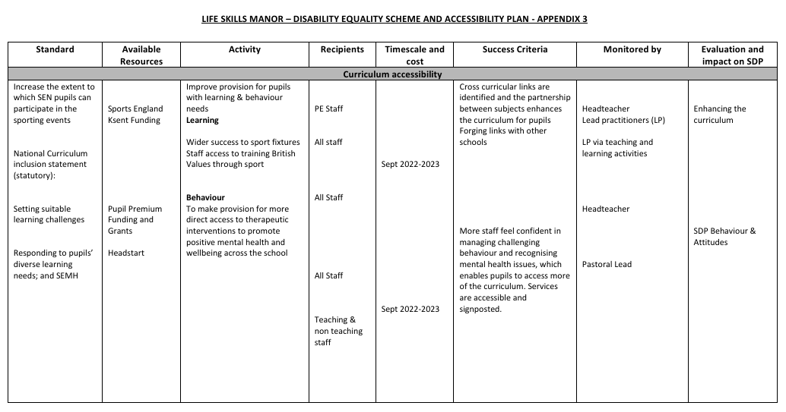
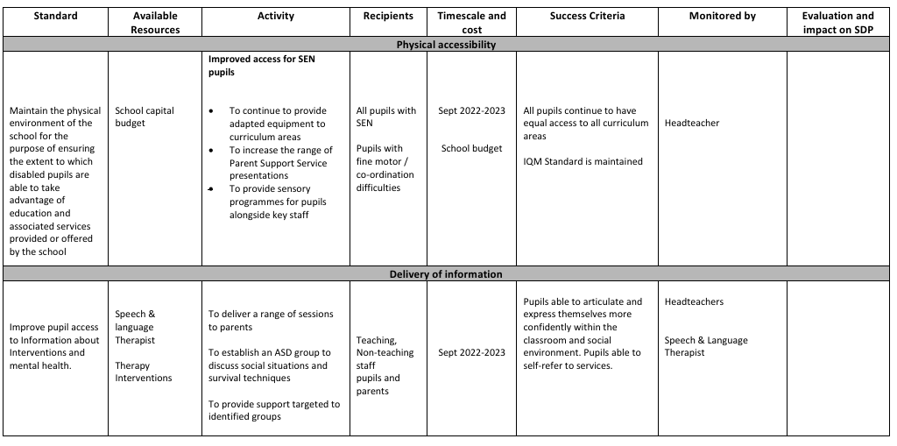

Appendix 3 - Gender Equality Action Plan
Curriculum Access |  | Activities | Lead Person | Timescale | Success Criteria | Monitored By
Achieve SMSC Quality Mark | • | Achieve all elements from The Standards framework | P Barrett | Sept 2022-2023 | SMSC Quality mark achieved. | P Barrett
LGBT awareness and inclusion monitored and maintained | • | Stonewall recognition | P Barrett | Sept 2022-2023 | Stonewall standard mark maintained | P Barrett
To review current procedures on uniform and dress codes to ensure equality of treatment | • | To liaise with staff and pupil group to identify any unfair practices | Paul Barrett  Staff Representatives | Sept 2022-2023 | Expectations and demands are fairly applied and benefit both sexes | P Barrett
Personnel |  | Activities | Lead Person | Timescale | Success Criteria | Monitored By
To ensure school staff code of conduct emergency dependants’ care leave/ personal leave is applied fairly and consistently across all staff, irrespective of age or gender | •  • | To communicate policy and procedures to all staff To ensure all staff are fairly advised | P Barrett | Sept 2022 and ongoing | School procedures are known by everyone, are fairly implemented and staff are confident and agree with policy | Governors
To ensure all job specifications are not gender biased unless there are exceptional reasons for recruiting a particular gender e.g. supervision of boys or girls changing rooms | • | To critically appraise all job specifications prior to any further appointments | P Barrett | Sept 2022 and ongoing | School fulfils its aims of being an equal opportunities employer | Governors
Document Title: | Policy – Single Equality Scheme
Version: | 1
Prepared by: | Rachel Beecham
Governing Body Acceptance Date: | Ratified at the FGB on the 25/01/2024
Date for Next Review: | February 2027
Link on School Website | https://www.lifeskillsmanor.co.uk/policies

