

Relationships and Sex Education Policy

Date – October 2025

Page | 1

Contents
1. Aims 3
2. Statutory requirements 3
3. Policy development 3
4. Definition 3
5. Curriculum 3
6. Delivery of RSE 4
7. Roles and responsibilities 4
8. Parents’ right to withdraw 5
9. Training 5
10. Monitoring arrangements 6
Appendix 1: Curriculum Map 7
Appendix 2: By the end of secondary school pupils should know 13

1. Aims
The aims of relationships and sex education (RSE) at our school are to:
- Provide a framework in which sensitive discussions can take place
- Prepare pupils for puberty, and give them an understanding of sexual development and the importance of health and hygiene
- Help pupils develop feelings of self-respect, confidence and empathy
- Create a positive culture around issues of sexuality and relationships
- Teach pupils the correct vocabulary to describe themselves and their bodies

2. Statutory requirements
We must provide relationships education to all our primary pupils as per section 34 of the Children and Social work act 2017.
In teaching RSE, we must have regard to guidance issued by the secretary of state as outlined in section 403 of the Education Act 1996.
At Life Skills Manor we teach RSE as set out in this policy.
We must provide RSE to all secondary pupils as per the Children and Social work act 2017.
In teaching RSE, we must have regard to to guidance issued by the secretary of state as outlined in section 403 of the Education Act 1996.

3. Policy development
This policy has been developed in consultation with staff, pupils and parents. The consultation and policy development process involved the following steps:
- Review – a member of staff or working group pulled together all relevant information including relevant national and local guidance

- Staff consultation – all school staff were given the opportunity to look at the policy and make recommendations

- Parent/stakeholder consultation – parents and any interested parties were invited to attend a meeting about the policy

- Pupil consultation – we investigated what exactly pupils want from their RSE

- Ratification – once amendments were made, the policy was shared with governors and ratified

4. Definition
RSE is about the emotional, social and cultural development of pupils, and involves learning about relationships, sexual health, sexuality, healthy lifestyles, diversity and personal identity.
RSE involves a combination of sharing information, and exploring issues and values.
RSE is not about the promotion of sexual activity.

5. Curriculum
Our curriculum is set out as per Appendix 1 but we may need to adapt it as and when necessary.

We have developed the curriculum in consultation with parents, pupils and staff, taking into account the age, needs and feelings of pupils. If pupils ask questions outside the scope of this policy, teachers will respond in an appropriate manner, so they are fully informed and don’t seek answers online.
Primary sex education will focus on:
- Preparing boys and girls for the changes that adolescence brings
- How a baby is conceived and born
For more information about our curriculum, see our curriculum map in Appendix 1.

6. Delivery of RSE
RSE is taught within the personal, social, health and economic (LIFE SKILLS) education curriculum. Biological aspects of RSE are taught within the science curriculum, and other aspects are included within interventions.
Pupils also receive stand-alone sex education sessions delivered by a trained health professional.
Relationships education focuses on teaching the fundamental building blocks and characteristics of positive relationships including:
- Families and people who care for me
- Caring friendships
- Respectful relationships
- Online relationships
- Being safe
RSE focuses on giving young people the information they need to help them develop healthy, nurturing relationships of all kinds including:
- Families
- Respectful relationships, including friendships
- Online and media
- Being safe
- Intimate and sexual relationships, including sexual health
For more information about our RSE curriculum, see Appendices 1 and 2.
These areas of learning are taught within the context of family life taking care to ensure that there is no stigmatisation of children based on their home circumstances (families can include single parent families, LGBT parents, families headed by grandparents, adoptive parents, foster parents/carers amongst other structures) along with reflecting sensitively that some children may have a different structure of support around them (for example: looked after children or young carers).

7. Roles and responsibilities

7.1 The governing board
The governing board will approve the RSE policy and hold the headteacher to account for its implementation.

7.2 The headteacher
The headteacher is responsible for ensuring that RSE is taught consistently across the school, and for managing requests to withdraw pupils from non-statutory components of RSE (see section 8).

7.3 Staff
Staff are responsible for:
- Delivering RSE in a sensitive way
- Modelling positive attitudes to RSE
- Monitoring progress
- Responding to the needs of individual pupils
- Responding appropriately to pupils whose parents wish them to be withdrawn from the non-statutory components of RSE
Staff do not have the right to opt out of teaching RSE. Staff who have concerns about teaching RSE are encouraged to discuss this with the headteacher or subject Curriculum Leader.

7.4 Pupils
Pupils are expected to engage fully in RSE and, when discussing issues related to RSE, treat others with respect and sensitivity.

8. Parents’ right to withdraw
Parents do not have the right to withdraw their children at primary age from relationships education.
Parents have the right to withdraw their children from the non-statutory components of sex education within RSE.
Requests for withdrawal should be put in writing using the form found in Appendix 3 of this policy and addressed to the headteacher.
Alternative work will be given to pupils who are withdrawn from sex education.
Parents have the right to withdraw their secondary aged children from the non-statutory components of sex education within RSE up to and until 3 terms before the child turns 16. After this point, if the child wishes to receive sex education rather than being withdrawn, the school will arrange this.
Requests for withdrawal should be put in writing using the form found in Appendix 3 of this policy and addressed to the headteacher.
A copy of withdrawal requests will be placed in the pupil’s educational record. The headteacher will discuss the request with parents and take appropriate action.
Alternative work will be given to pupils who are withdrawn from sex education.

9. Training
Staff are trained on the delivery of RSE as part of their induction and it is included in our continuing professional development calendar.
The headteacher will also invite visitors from outside the school, such as school nurses or sexual health professionals, to provide support and training to staff teaching RSE.

10. Monitoring arrangements
The delivery of RSE is monitored by Katie Wood, Curriculum Leader of PSHE through:
- Planning checks
- Deep dives
- Lesson visits
- Book monitoring

Pupils’ development in RSE is monitored by the class central teachers as part of our internal assessment systems.
This policy will be reviewed by Paul Barrett, Headteacher in charge of Teaching & Learning annually. At every review, the policy will be approved by the governing board and headteacher.

Appendix 1: Curriculum Map

Page | 7
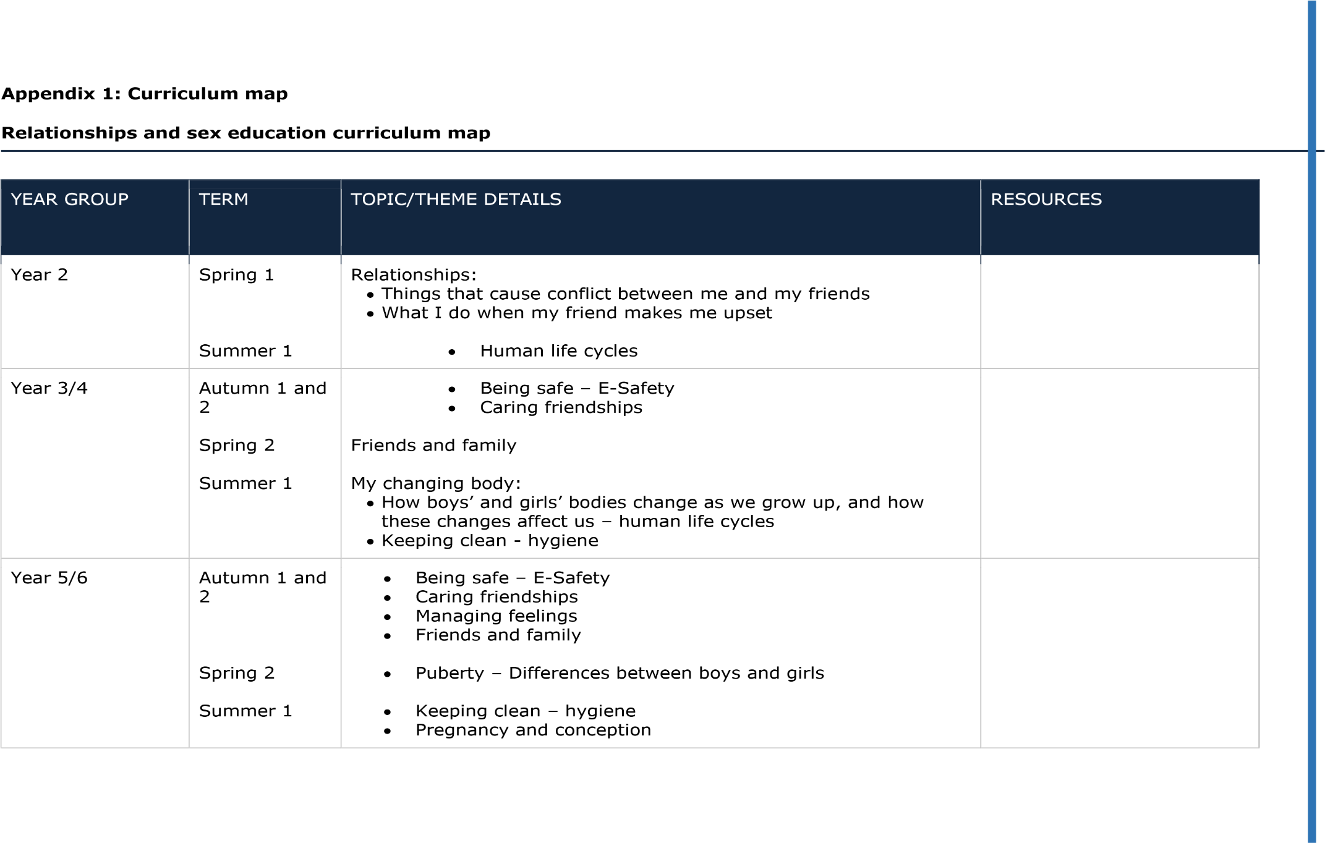
YEAR GROUP | TERM | TOPIC/THEME DETAILS | RESOURCES
Year 7 | Autumn 1  Autumn 2  Spring 1  Spring 2  Summer 1 | - Being safe – E-Safety  - Caring friendships  - Self-image  - Hygiene  - Puberty, changes, pregnancy and conception, STIs.
Year 8 | Autumn 1  Autumn 2  Spring 1  Spring 2  Summer 1 | - Being safe – E-Safety  - Caring friendships  - Self-image  - Hygiene  - Puberty, changes, pregnancy and conception, STIs, moral dilemmas
Year 9 | Autumn 1  Autumn 2  Spring 1  Spring 2  Summer 1 | - Being safe – E-Safety  - Caring friendships  - Self-image  - Hygiene, how to ask for help and where to go  - Puberty, changes, pregnancy and conception, STIs, moral dilemmas, contraception, looking after a baby
YEAR GROUP | TERM | TOPIC/THEME DETAILS | RESOURCES
KS4 | Autumn 1  Autumn 2  Spring 1  Spring 2  Summer 1  Summer 2 | - E-Safety, emotional and mental health  - Being safe, caring friendships  - Self-image  - Hygiene, being responsible  - Puberty, changes, pregnancy and conception, STIs, moral dilemmas, contraception, looking after a baby  - What it means to be an adult

Appendix 2: By the end of primary school pupils should know
TOPIC | PUPILS SHOULD KNOW
Families and people who care about me | - That families are important for children growing up because they can give love, security and stability  - The characteristics of healthy family life, commitment to each other, including in times of difficulty, protection and care for children and other family members, the importance of spending time together and sharing each other’s lives  - That others’ families, either in school or in the wider world, sometimes look different from their family, but that they should respect those differences and know that other children’s families are also characterised by love and care  - That stable, caring relationships, which may be of different types, are at the heart of happy families, and are important for children’s security as they grow up  - That marriage represents a formal and legally recognised commitment of two people to each other which is intended to be lifelong  - How to recognise if family relationships are making them feel unhappy or unsafe, and how to seek help or advice from others if needed
Caring friendships | - How important friendships are in making us feel happy and secure, and how people choose and make friends  - The characteristics of friendships, including mutual respect, truthfulness, trustworthiness, loyalty, kindness, generosity, trust, sharing interests and experiences and support with problems and difficulties  - That healthy friendships are positive and welcoming towards others, and do not make others feel lonely or excluded  - That most friendships have ups and downs, and that these can often be worked through so that the friendship is repaired or even strengthened, and that resorting to violence is never right  - How to recognise who to trust and who not to trust, how to judge when a friendship is making them feel unhappy or uncomfortable, managing conflict, how to manage these situations and how to seek help or advice from others, if needed

TOPIC | PUPILS SHOULD KNOW
Respectful relationships | - The importance of respecting others, even when they are very different from them (for example, physically, in character, personality or backgrounds), or make different choices or have different preferences or beliefs • Practical steps they can take in a range of different contexts to improve or support respectful relationships • The conventions of courtesy and manners  - The importance of self-respect and how this links to their own happiness  - That in school and in wider society they can expect to be treated with respect by others, and that in turn they should show due respect to others, including those in positions of authority  - About different types of bullying (including cyberbullying), the impact of bullying, responsibilities of bystanders (primarily reporting bullying to an adult) and how to get help  - What a stereotype is, and how stereotypes can be unfair, negative or destructive  - The importance of permission-seeking and giving in relationships with friends, peers and adults
Online relationships | - That people sometimes behave differently online, including by pretending to be someone they are not  - That the same principles apply to online relationships as to face-to face relationships, including the importance of respect for others online including when we are anonymous  - The rules and principles for keeping safe online, how to recognise risks, harmful content and contact, and how to report them  - How to critically consider their online friendships and sources of information including awareness of the risks associated with people they have never met  - How information and data is shared and used online
TOPIC | PUPILS SHOULD KNOW
Being safe | - What sorts of boundaries are appropriate in friendships with peers and others (including in a digital context)  - About the concept of privacy and the implications of it for both children and adults; including that it is not always right to keep secrets if they relate to being safe  - That each person’s body belongs to them, and the differences between appropriate and inappropriate or unsafe physical, and other, contact  - How to respond safely and appropriately to adults they may encounter (in all contexts, including online) whom they do not know  - How to recognise and report feelings of being unsafe or feeling bad about any adult  - How to ask for advice or help for themselves or others, and to keep trying until they are heard  - How to report concerns or abuse, and the vocabulary and confidence needed to do so  - Where to get advice e.g. family, school and/or other sources

Appendix 2: By the end of secondary school pupils should know
TOPIC | PUPILS SHOULD KNOW
Families | - That there are different types of committed, stable relationships  - How these relationships might contribute to human happiness and their importance for bringing up children  - What marriage is, including their legal status e.g. that marriage carries legal rights and protections not available to couples who are cohabiting or who have married, for example, in an unregistered religious ceremony  - Why marriage is an important relationship choice for many couples and why it must be freely entered into  - The characteristics and legal status of other types of long-term relationships  - The roles and responsibilities of parents with respect to raising of children, including the characteristics of successful parenting  - How to: determine whether other children, adults or sources of information are trustworthy: judge when a family, friend, intimate or other relationship is unsafe (and to recognise this in others’ relationships); and, how to seek help or advice, including reporting concerns about others, if needed

TOPIC | PUPILS SHOULD KNOW
Respectful relationships, including friendships | - The characteristics of positive and healthy friendships (in all contexts, including online) including: trust, respect, honesty, kindness, generosity, boundaries, privacy, consent and the management of conflict, reconciliation and ending relationships. This includes different (non-sexual) types of relationship  - Practical steps they can take in a range of different contexts to improve or support respectful relationships  - How stereotypes, in particular stereotypes based on sex, gender, race, religion, sexual orientation or disability, can cause damage (e.g. how they might normalise non-consensual behaviour or encourage prejudice)  - That in school and in wider society they can expect to be treated with respect by others, and that in turn they should show due respect to others, including people in positions of authority and due tolerance of other people’s beliefs  - About different types of bullying (including cyberbullying), the impact of bullying, responsibilities of bystanders to report bullying and how and where to get help  - That some types of behaviour within relationships are criminal, including violent behaviour and coercive control  - What constitutes sexual harassment and sexual violence and why these are always unacceptable  - The legal rights and responsibilities regarding equality (particularly with reference to the protected characteristics as defined in the Equality Act 2010) and that everyone is unique and equal
Online and media | - Their rights, responsibilities and opportunities online, including that the same expectations of behaviour apply in all contexts, including online  - About online risks, including that any material someone provides to another has the potential to be shared online and the difficulty of removing potentially compromising material placed online  - Not to provide material to others that they would not want shared further and not to share personal material which is sent to them  - What to do and where to get support to report material or manage issues online  - The impact of viewing harmful content  - That specifically sexually explicit material e.g. pornography presents a distorted picture of sexual behaviours, can damage the way people see themselves in relation to others and negatively affect how they behave towards sexual partners  - That sharing and viewing indecent images of children (including those created by children) is a criminal offence which carries severe penalties including jail  - How information and data is generated, collected, shared and used online
TOPIC | PUPILS SHOULD KNOW
Being safe | - The concepts of, and laws relating to, sexual consent, sexual exploitation, abuse, grooming, coercion, harassment, rape, domestic abuse, forced marriage, honour-based violence and FGM, and how these can affect current and future relationships  - How people can actively communicate and recognise consent from others, including sexual consent, and how and when consent can be withdrawn (in all contexts, including online)
Intimate and sexual relationships, including sexual health | - How to recognise the characteristics and positive aspects of healthy one-to-one intimate relationships, which include mutual respect, consent, loyalty, trust, shared interests and outlook, sex and friendship  - That all aspects of health can be affected by choices they make in sex and relationships, positively or negatively,  e.g. physical, emotional, mental, sexual and reproductive health and wellbeing  - The facts about reproductive health, including fertility and the potential impact of lifestyle on fertility for men and women  - That there are a range of strategies for identifying and managing sexual pressure, including understanding peer pressure, resisting pressure and not pressurising others  - That they have a choice to delay sex or to enjoy intimacy without sex  - The facts about the full range of contraceptive choices, efficacy and options available  - The facts around pregnancy including miscarriage  - That there are choices in relation to pregnancy (with medically and legally accurate, impartial information on all options, including keeping the baby, adoption, abortion and where to get further help)  - How the different sexually transmitted infections (STIs), including HIV/AIDs, are transmitted, how risk can be reduced through safer sex (including through condom use) and the importance of and facts about testing  - About the prevalence of some STIs, the impact they can have on those who contract them and key facts about treatment  - How the use of alcohol and drugs can lead to risky sexual behaviour  - How to get further advice, including how and where to access confidential sexual and reproductive health advice and treatment

Appendix 3: Parent form: withdrawal from sex education within RSE

TO BE COMPLETED BY PARENTS
Name of child |  | Class
Name of parent |  | Date
Reason for withdrawing from sex education within relationships and sex education
Any other information you would like the school to consider
Parent signature

TO BE COMPLETED BY THE SCHOOL
Agreed actions from discussion with parents | Include notes from discussions with parents and agreed actions taken.  Eg: Joe Pupil A will be taking part in all relationship lessons and during the sex education lessons, he will be working independently on a project in the Year 6 classroom

Document Title: | RSE Policy
Version:
Prepared by: | Sophie Chidwick
Governing Body Acceptance Date:
Date for Next Review: | October 2026
Link on School Website

