

Trips, Visits and Educational Visits Policy
Prepared by: The Central Team
Date: June 2025
Version: V1

CONTENTS
Introduction
1. Aims and scope
2. Legislation and guidance
3. Roles and responsibilities
4. Planning and preparation
5. Risk assessment
6. Communication and consent
7. Emergency procedures and incident reporting
8. Charging and insurance (remove if not applicable)
9. Residential visits
10. Links with other policies
Appendix 1: Trip Request Form
Appendix 2: Trip Risk Assessment Template(s)
Appendix 3: Trip Lunch Request form
Contact Information
Approval & Policy Review
Revision History

Introduction

Life Skills Manor School is owned and operated by Cavendish Education.

This policy is one of a series of school policies that, taken together, are designed to form a comprehensive statement of the school’s aspiration to provide an outstanding education for each of its students and of the mechanisms and procedures in place to achieve this. Accordingly, this policy should be read alongside these policies. In particular, it should be read in conjunction with the policies covering equality and diversity, Health and Safety, safeguarding and child protection.

All of these policies have been written, not simply to meet statutory and other requirements, but to enable and evidence the work that the whole school is undertaking to ensure the implementation of its core values: To Deliver young people aged 10-18 that focuses on preparing students for independent, fulfilling adult lives through a highly tailored curriculum.

While this current policy document may be referred to elsewhere in Life Skills Manor School documentation, including particulars of employment, it is non-contractual.

In the school’s policies, unless the specific context requires otherwise, the word “parent” is used in terms of Section 576 of the Education Act 1996, which states that a ‘parent’, in relation to a child or young person, includes any person who is not a biological parent but who has parental responsibility, or who has care of the child. Department for Education guidance Understanding and dealing with issues relating to parental responsibility updated August 2023, considers a ‘parent’ to include:
- all biological parents, whether they are married or not
- any person who, although not a biological parent, has parental responsibility for a child or young person - this could be an adoptive parent, a step-parent, guardian or other relative
- any person who, although not a biological parent and does not have parental responsibility, has care of a child or young person

A person typically has care of a child or young person if they are the person with whom the child lives, either full or part-time, and who looks after the child, irrespective of what their biological or legal relationship is with the child.

The school contracts the services of third-party organisations to ensure regulatory compliance and implement best practices for:
- HR and Employment Law
- Health & Safety Guidance
- DBS Check processing
- Mandatory Safeguarding, Health & Safety, and other relevant training
- Data protection and GDPR guidance
- Specialist insurance cover
Where this policy refers to ‘employees’, the term refers to any individual who is classified as an employee or a worker, working with and on behalf of the school (including volunteers and contractors).

The school is committed to safeguarding and promoting the welfare of children and young people and expects all staff, volunteers, pupils and visitors to share this commitment.

All outcomes generated by this document must take account of and seek to contribute to safeguarding and promoting the welfare of children and young people at Life Skills Manor School.

The policy documents of Life Skills Manor School are revised and published periodically in good faith. They are inevitably subject to revision. On occasions, a significant revision, although promulgated in school separately, may have to take effect between the republication of a set of policy documents. Care should therefore be taken to ensure, by consultation with the Senior Leadership Team, that the details of any policy document are still effectively current at a particular moment.

1. Aims and scope
Educational visits are activities arranged by, or on behalf of, our school, which require pupils to leave the school premises, having been authorised to do so by the headteacher or other designated member of staff.

Educational visits are a valuable way to supplement and enhance the curriculum, expand pupils’ education and provide enriching social and cultural experiences, teach life skills and promote independent learning, provide a foundation for lifelong learning], and form an integral part of our approach to furthering our pupils’ education and personal growth.

This policy sets out our approach to planning and operating educational visits, to ensure the health and safety of our pupils and staff, and to make sure that our visits are available to all pupils. It sets out the roles and responsibilities of staff, pupils and volunteers when it comes to visits.
This policy applies to activities taking place within and outside of normal school hours, including weekends and holiday periods. This includes (but is not limited to):

- Visits to places of interest in the local area
- Day visits to places such as museums and other cultural and educational institutions
- Sporting activities
- Adventurous and recreational activities
- Residential trips organised by the school
- Trips abroad organised by the school

2. Legislation and guidance
This policy is based on the Department for Education’s guidance on health and safety on educational visits, and the following legislation and statutory guidance:

- Equality Act 2010
- SEND Code of Practice
- Keeping Children Safe in Education 2025

3. Roles and responsibilities
  - Headteacher
The headteacher is responsible for:
- Approving staff requests for educational visits, including having the final authority to approve any educational visit of less than 24 hours
- Making sure staff, including the educational visits co-ordinator, have received any necessary training
- Working with the governing board to approve residential trips of more than 24 hours

  - The educational visits co-ordinator (EVC)

Craig Kelly, is the appointed EVC at our school. Their role is to:

- Oversee and guide other staff to arrange and organise educational visits
- Assess the ability of other staff to lead visits and designate a suitable trip lead for each visit
- Assess outside activity providers
- Advise the headteacher and governing board when they’re approving trips
- Access the necessary training, advice and guidance
- Evaluate all visits once complete, from planning to the visit itself, and use this to improve future arrangements

3.3 Trip leader
Every educational visit will have 1 member of staff designated as the trip lead. The trip leader will:

- Plan the proposed visit, taking into account the health and safety risks to pupils, staff and volunteers
- Assign staff and volunteer roles, as needed
- Make sure the school has accurate and up-to-date information about the trip destination, to be used in risk assessments
- Make sure the needs of everyone taking part are considered, including coordinating any additional support needed
- Make sure parents and carers are given accurate information about educational visits, including any costs or necessary equipment not supplied by the school or a third party
- Communicate key details about the visit and all locations to staff, pupils and parents/carers, including roles and responsibilities and expected behaviour
- Make sure staff are capable and able to fulfil their roles at all times while responsible for pupils and others

3.4 Staff
Staff have a responsibility to make sure all pupils and staff who take part in visits are kept safe and understand the proper way to prepare for trips, as well as how to act while taking part. Staff will:

- Seek and obtain approval for all educational visits from the headteacher
- Carry out any required risk assessments and work with the trip lead
- Communicate with parents and carers, and make sure trips are inclusive of all pupils’ needs
- Look out for the health and safety of themselves and those around them
- Help manage pupil behaviour and discipline as required while on the visit
- Share any concerns or worries with the trip lead and others, as appropriate

3.5 Parents and carers
By agreeing that pupils can take part in educational visits, parents/carers agree that they will:

- Provide all information required, such as emergency contact details and health/medicine information if applicable
- Sign and return consent forms and any other documentation required promptly
- Share any concerns or information about the pupil that may affect or impact their ability to safely take part in the trip

3.6 Pupils
Our school behaviour policy also applies to all educational visits. This includes the expectation that pupils will:

- Follow the instructions given to them while on the trip
- Dress and behave as expected for the length of the trip
- Take responsibility for their safety and the safety of others, reporting any concerns to a staff member or trip supervisor

Pupils will always be reminded of our behaviour expectations before going off-site for a visit and will be expected to uphold the school’s behaviour policy at all times.

4. Planning and preparation
The decision on whether or not a visit will take place will be made by Craig Kelly or Mickey Capeling, and based on factors including:

- Cost (including any potential cost to parents/carers)
- Timing in the school year and any potential clashes
- Educational purpose and value
- Disruption to the normal running of the school
- Health and safety considerations
- Staff-to-pupil ratio
- Inclusion and accessibility
- Availability of school transport

As part of the planning stage, information will be gathered by staff proposing the visit, including:

- Location and travel distance
- Travel plans or options
- Full cost breakdown, including multiple options where available
- Resources, including staffing, volunteers, and physical supplies
- Accommodation options, where needed
- Insurance details, where needed
- Risk assessment plans and first aid provision
- What safety measures can be put in place in order to reduce any risks

See Appendix 1 for the Trip Request form.

In cases where a trip involves activities for more than 24 hours, an overnight stay and/or travel overseas, the headteacher will seek approval from the governing board.

Once the risk assessment has been approved by the headteacher and the governing board, where relevant, staff will communicate with parents/carers and provide trip information.

Written parental consent will be required for trips that take place outside of normal school hours and for any trips requiring a higher-than-normal level of risk assessment.

We will evaluate each visit after its conclusion, from the planning through to the visit itself, to continually improve the planning and experience of our future visits.

4.1. Inclusion
All pupils, regardless of background or abilities, should be able to take part in every aspect of our school life, including visits.

SEND
If a pupil with a disability or an education, health and care (EHC) plan, or any other specific needs (e.g. medical conditions including allergies) is participating in the visit, they will have the same support that is available to them during the school day.

We will adjust the trip programme where necessary, working with parents/carers to provide additional support, making reasonable adjustments to itineraries, providing additional support staff, and other adjustments as appropriate.

Additional risk assessments may be carried out to ensure the safety of all staff and pupils.

Challenging behaviour
In some cases, it may be reasonable and necessary to prevent a pupil with challenging behaviour from coming on a trip to protect their safety and the safety of the other pupils attending.
We will consider all reasonable options to help the pupil go on the trip safely, such as adapting the trip itinerary and increasing staffing numbers so the pupil can be supervised on a 1:1 basis.

5. Risk assessment
We will carry out a full risk assessment at least 2 weeks before the start of all trips.

This will be completed using the school’s risk assessment template see Appendix 2, and approved by Craig Kelly. Existing risk assessments which can be found via Brightsafe or by seeing Craig Kelly or those provided by the destination itself might also be used to support this process.

The risk assessment will include any specific medical issues and allergies (for staff and pupils), the role of additional support on the visit, specified activities to be carried out, as well as risks associated with transport to and from the destination.

Where practical, staff may make a preliminary visit to the trip destination as part of the planning and risk assessment process, but this is not mandatory.
Trip leads will raise any concerns or questions about potential risks and safety measures with the headteacher and, where appropriate, third-party vendors.

Every risk assessment will be approved by Craig Kelly, a copy taken on the visit and another copy left with the PA to the head teacher.

5.1 Staff ratios and first aid
Risk assessments for each visit will ascertain the safe level of supervision required. On all educational visits, we will make sure:

- At least 1 male and 1 female supervising adult are present (for mixed pupil groups)
- At least 1 supervising adult able to administer first aid is present on all trips
- Appropriate first aid equipment will be taken on all trips, in accordance with the school’s first aid and health and safety policies. These can be found on the school website.
- All supervising adults will be made aware of any medical issues or allergies at the start of the trip
- Adults without a DBS check will not be left alone with pupils at any time
- The trip lead will take regular headcounts and/or roll calls

5.2 Transport
Transportation for trips will be organised by the school, in line with our safety procedures. We will make sure pupils, staff and volunteers are transported safely and efficiently, with the required first aid provision.

Unless previously agreed with parents, transport for visits will leave from and return to the school site.

5.3 Use of external organisations
As part of the risk assessment process, we will check that any external organisations providing an activity have appropriate safety standards and liability insurance.

This includes checking that organisations hold the Learning Outside the Classroom (LOtC) Quality Badge. Where an organisation does not, we will check additional details as outlined in the DfE’s guidance on health and safety on educational visits to make sure it’s an appropriate organisation to use.

We will have a written agreement in place with each external organisation outlining what everyone is responsible for during the activity.

6. Communication and consent
We will contact the parents and carers of pupils invited to take part in an educational visit at least 1 week (5 working days) before the proposed date of the trip. Communication will be via Email (Dojo) and information provided will include the date, travel times, destination, purpose of the visit, and the size of the group attending.

We will also communicate:

- Times and details of travel, including drop-off and pick-up times and location
- Pupil-to-staff ratios and staff qualifications, where relevant
- Clothing and equipment required, and whether this is provided by the school
- Expected behaviour and consequences of pupils’ failure to meet these standards

Where required, parents/carers will be asked to provide written consent for educational visits by signing and dating a form to be returned to the school.

Because most visits during the school day will be part of the curriculum, we will not always need written consent. However, we will always inform parents/carers as above about any off-site visits, and give them an opportunity for them to withdraw their child.

Parents/carers will also be asked to provide current and relevant medical information and dietary requirements, as well as emergency contact numbers where they can be reached.
In the case of overseas trips, they will be asked to provide passport information and European Health Insurance Card or UK Global Health Insurance Card information, if available.

7. Emergency procedures and incident reporting
Generally, emergency planning will be defined as planning for:
- Serious and unexpected risk
- Serious and life-threatening injury
- Individuals going missing
- A serious breach of safeguarding expectations

The trip leader will be familiar with these plans for each visit.

In the case of an emergency, the trip leader or other supervising adult will contact the school office. The school office will then contact parents/carers as required, and inform them of changes to plans or cancellations of trips and/or alternative travel plans. This will form part of a wider communication plan that covers how routine communications should be handled in such situations.

1 member of staff will always accompany a pupil seeking medical treatment.
In a case of a pupil being unaccounted for, the trip leader will search the area while another member of staff remains in charge of the other pupils. In the unlikely event that a pupil cannot be found within 30 minutes, the trip leader will contact the school office, who will notify the parents/carers. The trip leader will then contact the police and provide them with the relevant information so they can take over the search, staying with them to comfort the pupil when found. The remaining staff and adults will return to the school with the rest of the pupils.

All incidents and accidents will be reported in line with our health and safety policy, including required reporting to Ofsted and the Health and Safety Executive (HSE).

Smaller incidents, accidents or near misses that do not require external reporting will still be covered by an internal report, to include steps that can be taken in the future to avoid similar incidents.
There will also be a clear process for evaluating all visits and trips once they have been concluded, from the planning through to the visit itself. This will help with evaluating whether planning worked and to learn from any incidents that took place.

8. Charging and insurance

Parents/carers won’t be asked to pay for any educational visit that takes place during school hours. They also won’t be asked to pay for any educational visit that takes place outside of school hours if it is part of the National Curriculum, a syllabus for a prescribed public examination, or religious education.
Where necessary, we may ask for a voluntary contribution to the costs of educational visits, but this will be entirely optional (except for residential visits) and will not affect pupils’ ability to take part fully in the trip.

We will make sure adequate insurance is in place for all trips, including, but not limited to: cancellation insurance for contracts with external providers, travel insurance, accident and medical cover, and loss of luggage and other personal items.

9. Residential visits
The headteacher, together with the governing board, will approve all residential trips longer than 24 hours.

The planning and preparation laid out in this policy will apply to residential visits as well as 1-day visits. In addition, the trip leader will make sure:

- Staff have received any necessary training
- All necessary permissions and medical forms are obtained at least 1 month before the start of the trip
- All adults, including volunteers, have had adequate safeguarding checks. Where appropriate – e.g. if the volunteer will be in direct unsupervised contact with pupils – this will include relevant DBS checks

Parents and carers will be given information about the visit and asked for permission at least 3 months before the first day of the visit. Information shared with parents will include:

- The dates and times of departure and return to school
- The full address and contact details of the destination
- Planned activities and options
- Meal provision
- Costs and optional charges, including deposits and the date by which this must be received, in line with our charging and remissions policy (this will include information about exemptions)
- Clothing and equipment provided, and what pupils must bring themselves
- Public health requirements, including any required vaccinations
- Accommodation options and arrangements
- The names of the staff attending

For visits abroad, we will make sure that any organisation providing activities holds the LOtC Quality badge or similar local accreditation. We will follow the Foreign and Commonwealth Office’s overseas travel guidance and foreign travel advice when organising these visits.

10. Links with other policies
This policy links with the following policies and procedures:

- Health and safety policy
- Charging and remissions policy
- Behaviour policy
- Child protection policy
- First aid policy
- Supporting pupils with medical conditions policy
- Special educational needs (SEN) policy
- Equality information and objectives
- Accessibility plan

Appendix 1: Trip Request form
Link via google docs.
https://docs.google.com/document/d/1iaZCNojhKgm0GYH3OCnQwPr03-y2LTZh/edit

To be completed by the staff member proposing the educational visit and submitted to Craig Kelly.

Appendix 2: Risk Assessment Template – Trips

Link via google docs
https://docs.google.com/document/d/13QJLVyz4EfWFO6r1j-ZYL0O042S5bmJm/edit

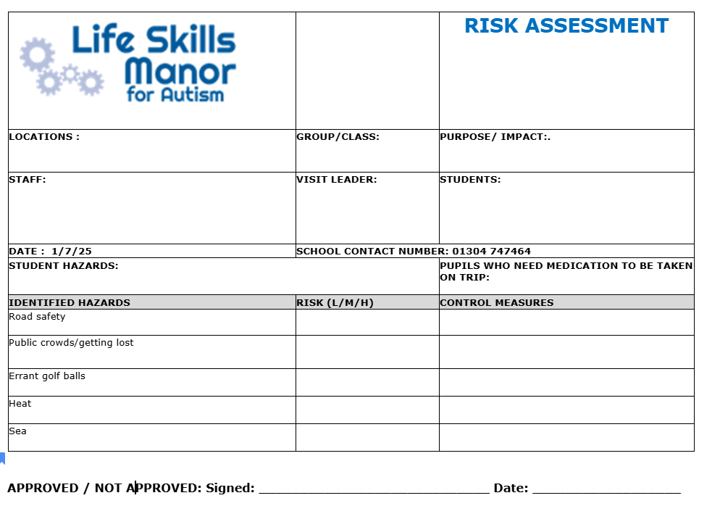

To be completed by the staff member proposing the educational visit and submitted to the Deputy head teacher and or Head teacher

Appendix 3: Trip Lunch request form

Link via google docs
https://docs.google.com/document/d/1k4FNbWX2UCBerQ7dqdP2QXkzhF_AjOSP/edit

Educational Visits Policy

Contact Information
For any questions or concerns regarding this policy, please contact the Head Teacher or Deputy Head Teacher.

Approval & Policy Review

This Policy has been reviewed and approved by:

Policy Approver(s) | Cavendish Education Board of Directors/Senior Leadership Team of the school
Storage Location | School Website , hard copy in the schools
Effective Date | June 2025
Next Review Date | June 2027

Revision History

Version | Change | Author | Date of Change

